**Statistical Testing**

1. **Player Performance Evaluation**

# Calculate goals per match

players['Goals_per_match'] = players['goals'] / players['games']

# Display top scorers based on goals per match

top_scorers = players.sort_values(by='Goals_per_match', ascending=False).head(10)

top_scorers[['player', 'Goals_per_match']]

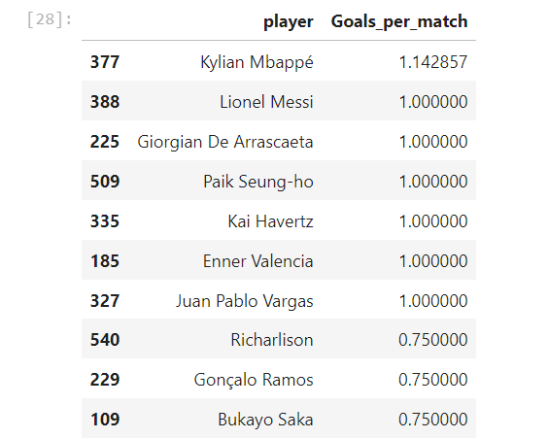

1. **Predicting Match Outcomes**

# Since matches have no result we use a proxy for Match_Result based on goals

# This is a simplified approach to adjust it as needed for our data.

teams['Match_Result'] = (teams['goals'] > teams['goals'].mean()).astype(int)

from sklearn.model_selection import train_test_split

from sklearn.linear_model import LogisticRegression

from sklearn.metrics import accuracy_score

# Calculate Pass Accuracy

teams['Pass_Accuracy'] = (teams['passes_completed'] / teams['passes']) * 100

# Prepare data for training

features = teams[['goals', 'possession', 'Pass_Accuracy']]

labels = teams['Match_Result']

# Split data

X_train, X_test, y_train, y_test = train_test_split(features, labels, test_size=0.2, random_state=42)

# Train the model

model = LogisticRegression()

model.fit(X_train, y_train)

# Test the model

predictions = model.predict(X_test)

print("Accuracy:", accuracy_score(y_test, predictions))

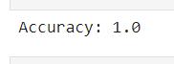

1. **Improved Tactical Understanding**

from sklearn.cluster import KMeans

import matplotlib.pyplot as plt

# Calculate Pass Accuracy

teams['Pass_Accuracy'] = (teams['passes_completed'] / teams['passes']) * 100

# Apply clustering (excluding Goals_Conceded if not available)

kmeans = KMeans(n_clusters=4, random_state=0).fit(teams[['possession', 'Pass_Accuracy']])

teams['Play_Style'] = kmeans.labels_

# Visualize clusters

plt.scatter(teams['possession'], teams['Pass_Accuracy'], c=teams['Play_Style'], cmap='viridis')

plt.xlabel('Possession')

plt.ylabel('Pass Accuracy')

plt.colorbar(label='Play Style Cluster')

plt.show()

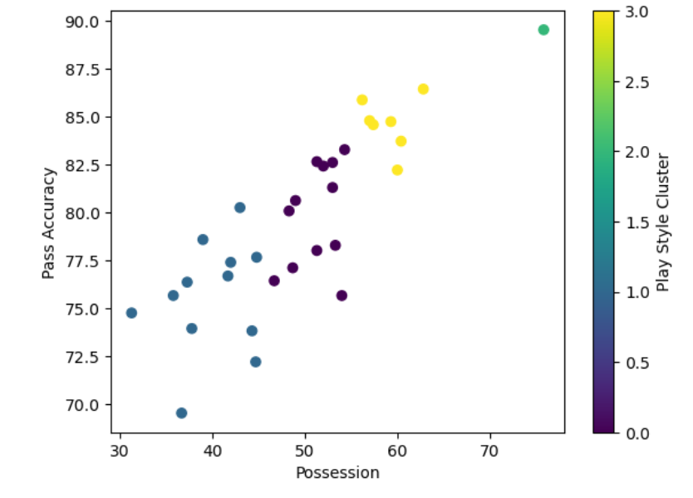

1. **Team Management and Player Selection**

# Check players with position as 'Forward'

forwards = players[players['position'] == 'FW']

print("Total forwards:", len(forwards))

# Check players with Goals per Match greater than 0.3

high_scorers = players[players['Goals_per_match'] > 0.3]

print("Total high scorers:", len(high_scorers))

# Try a lower threshold for Goals per Match

selected_players = players[(players['position'] == 'FW') & (players['Goals_per_match'] > 0.1)]

selected_players = selected_players.sort_values(by='Goals_per_match', ascending=False).head(3)

print(selected_players[['player', 'Goals_per_match']])

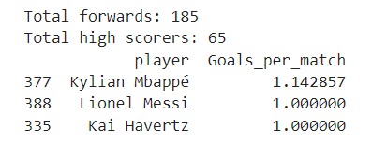

1. **World Cup Wins Analysis**

# Count the number of World Cups each country has won

world_cup_wins = world_cups['Winner'].value_counts()

print(world_cup_wins)

# Plot world cup wins

world_cup_wins.plot(kind='bar', title="World Cup Wins by Country")

plt.xlabel("Country")

plt.ylabel("World Cups Won")

plt.show()

